**AI Assisted Coding - Lab Test 1**

**Q1. Code Generation with Conditions (5M)**

**Prompt :** Generate a python program that accepts a year as input and check whether it is a leap year or not using conditional statements

**Code :**

# Accept year input from user and strip extra spaces/dots

year_input = input("Enter a year: ").strip().replace(".", "")

# Convert to integer

year = int(year_input)

# Check for leap year conditions

if (year % 4 == 0):

    if (year % 100 == 0):

        if (year % 400 == 0):

            print(year, "is a leap year.")

        else:

            print(year, "is not a leap year.")

    else:

        print(year, "is a leap year.")

else:

    print(year, "is not a leap year.")

**Output :**

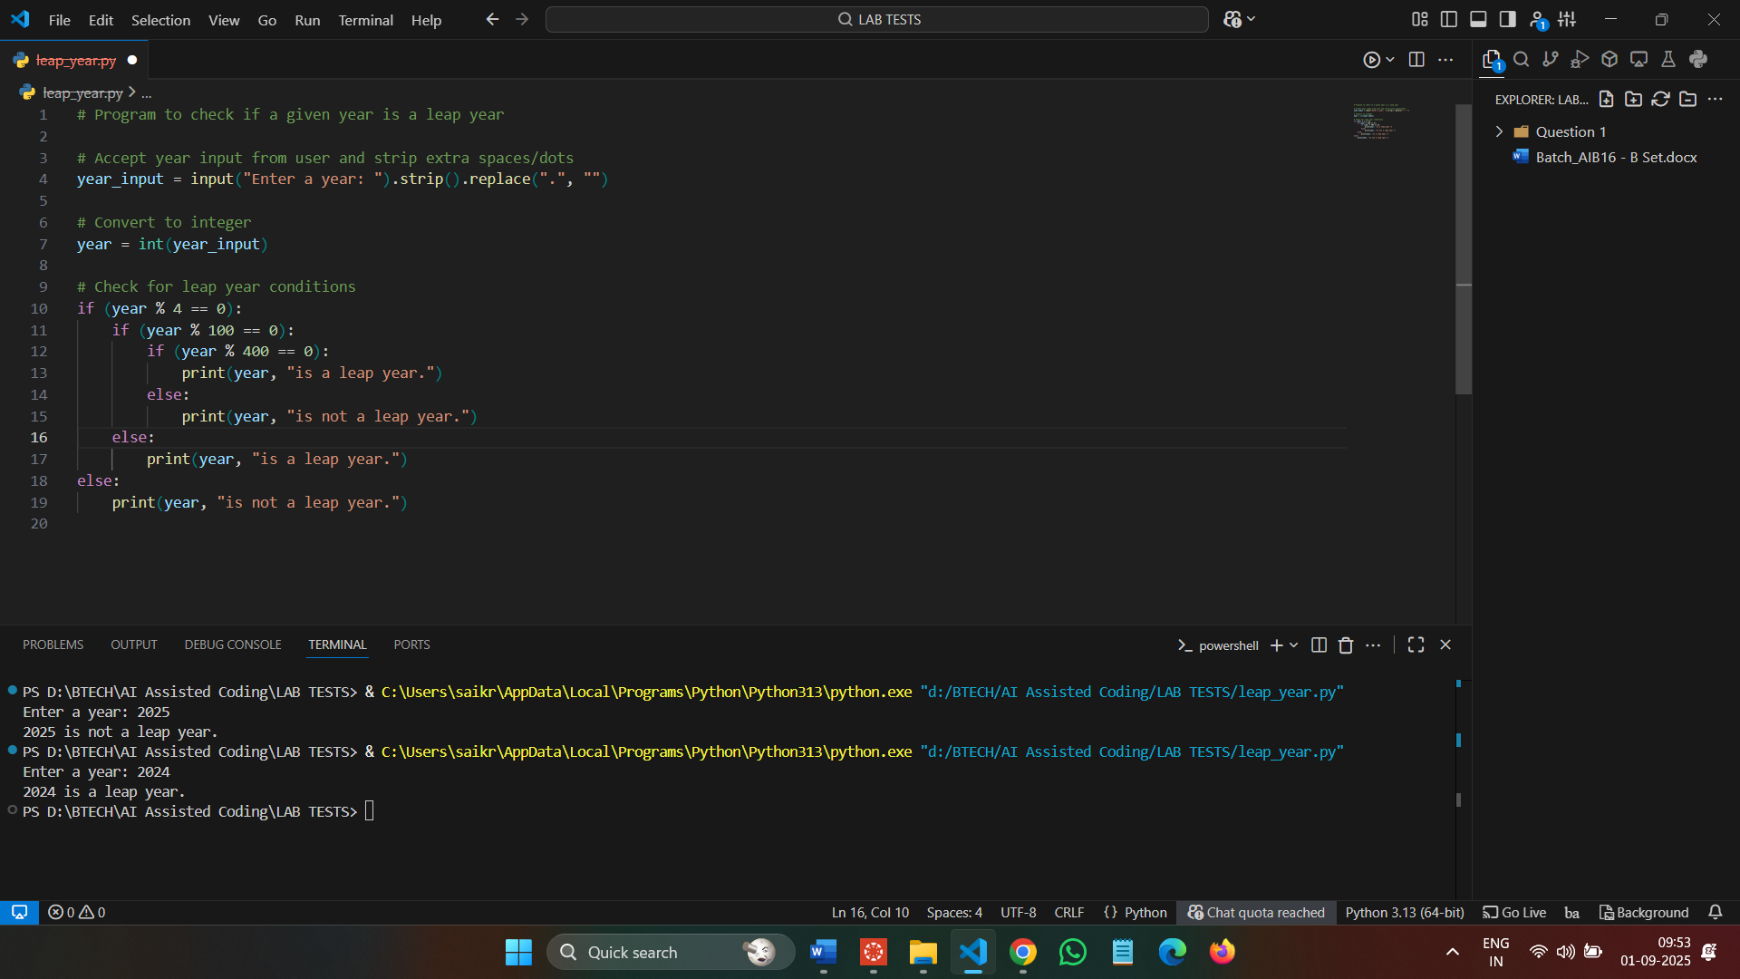

**Observation :**

The program checks whether a given year is a leap year or not. A year is a leap year if it is divisible by 4, except years divisible by 100, unless they are also divisible by 400. The program takes a year as input and prints whether it is a leap year following these rules.